AIE425 Intelligent Recommender Systems, Fall Semester 25/26
Final Course Project
Group 9, Shereef Bakr 221100940, Danial Maged 221100252, Ziad Diaa 221101044 Ahmed Nasr 221101223
Submission Date: Monday, January 5, 2026

Section 1

Dimensionality Reduction for Collaborative Filtering
Collaborative filtering systems aim to predict missing user–item ratings by leveraging historical user behavior. In large-scale recommender datasets, such as MovieLens, the rating matrix is typically high-dimensional and highly sparse. This sparsity makes direct similarity computation unreliable and computationally expensive. Dimensionality reduction techniques address this challenge by projecting the original data into a lower-dimensional space that captures the most informative patterns while reducing noise and redundancy.
In this section, three dimensionality reduction approaches are examined: Principal Component Analysis (PCA) with mean-filling, PCA with Maximum Likelihood Estimation (MLE), and Singular Value Decomposition (SVD). All experiments are conducted on a subset of the MovieLens 20M dataset that satisfies the project’s minimum requirements in terms of users, items, and ratings. Only the raw rating data were used; no outputs from previous assignments were reused.
Dataset Preparation
A user–item rating matrix was constructed from the MovieLens dataset, with users represented as rows and items as columns. Ratings follow the standard MovieLens scale ranging from 0.5 to 5.0. Due to the inherent sparsity of the data, many ratings were missing. Two target items, denoted I1 and I2, were selected based on popularity to ensure sufficient available ratings for evaluation. For prediction experiments, a subset of ratings for each target item was withheld and used as ground truth.
PCA with Mean-Filling
In the first approach, missing ratings were replaced using item-level mean-filling. Each unrated entry was filled with the average rating of the corresponding item, resulting in a complete matrix. An item–item covariance matrix was then computed, and PCA was applied to extract principal components. Using the transformed representation, the top-5 and top-10 most similar peers were identified for each target item. Users were projected into a reduced-dimensional space, and missing ratings were reconstructed accordingly.
Prediction accuracy was evaluated using Mean Absolute Error (MAE) and Root Mean Squared Error (RMSE). Runtime and memory usage were also recorded. The results indicate that PCA with mean-filling performs reasonably well for a small number of peers. However, increasing the number of peers led to a slight degradation in accuracy, likely due to noise introduced by the artificially filled values.
PCA with Maximum Likelihood Estimation
To mitigate the limitations of mean-filling, PCA with Maximum Likelihood Estimation was implemented. In this approach, the covariance between item pairs was computed using only

users who rated both items. If no overlapping users existed, the covariance was set to zero. PCA was then applied to the resulting covariance matrix.
Compared to mean-filling, PCA with MLE achieved improved prediction accuracy, particularly when using a larger number of peers. This improvement can be attributed to more reliable covariance estimates based solely on observed ratings. However, this method incurred significantly higher computational cost due to repeated overlap checks during covariance estimation.
Singular Value Decomposition
Singular Value Decomposition was applied to the completed rating matrix following mean-filling. The matrix was decomposed into three components representing user factors, item factors, and singular values. Orthogonality of the resulting matrices was verified numerically.
A scree plot of the singular values revealed a dominant first component followed by a gradual decay, indicating that much of the variance is captured by a small number of latent factors. Truncated SVD was then performed using different values of k (5, 20, 50, and 100). For each value of k, the matrix was reconstructed and evaluated using MAE and RMSE.
The reconstruction error remained relatively stable across increasing values of k, suggesting early saturation of the captured structure. While SVD provided strong global reconstruction, it was less effective than PCA-based methods for target-item prediction.
Comparative Analysis
Overall, PCA with mean-filling offered the fastest and most memory-efficient solution but suffered from reduced accuracy as the number of peers increased. PCA with MLE achieved the highest prediction accuracy but required substantially more computation. SVD provided a balanced approach for global approximation but was less specialized for predicting individual target items.

Conclusion
This section demonstrated how different dimensionality reduction techniques address sparsity in collaborative filtering. PCA with MLE showed the strongest predictive performance when sufficient overlapping data were available, highlighting the importance of accurate covariance estimation. The experiments emphasize that method selection should consider dataset characteristics, computational constraints, and the specific prediction objective.
Lessons Learned
Key challenges encountered included handling sparsity and balancing accuracy with efficiency. These challenges were addressed through careful data preparation, controlled evaluation, and systematic comparison. The results provide practical insight into the behavior of matrix factorization techniques in real-world recommender systems

Section 2

Introduction
Domain description and background
Recommender systems play a critical role in modern digital platforms by addressing the problem of information overload. In domains such as online movie streaming, users are faced with an enormous catalog of available content, making manual discovery inefficient and often unsatisfactory. Personalized recommendation systems aim to mitigate this issue by automatically suggesting items that align with users’ preferences and historical behavior.
This project focuses on the design and implementation of an intelligent movie recommendation system using a subset of the MovieLens 20M dataset. The system explores three complementary recommendation paradigms: content-based filtering, collaborative filtering, and a hybrid approach that combines both. The objective is to analyze how different recommendation strategies perform under realistic conditions, particularly in the presence of sparse data and cold-start users.
Several key challenges are addressed in this work. First, real-world recommendation datasets are inherently sparse, as most users interact with only a small fraction of available items. Second, new users or users with very limited interaction histories pose the cold-start problem, which can significantly degrade recommendation quality. Finally, scalability and efficiency must be considered when dealing with large datasets such as MovieLens 20M. This section documents how these challenges are handled through data preparation, feature engineering, model design, and evaluation.

Data And Methodology
Dataset Description
The experiments in this project are based on the MovieLens 20M dataset, a widely used benchmark dataset in recommender system research. The original dataset contains approximately 20 million user–movie ratings collected from thousands of users across tens of thousands of movies. Each rating is provided on a scale from 0.5 to 5.0, in increments of 0.5.
To meet the project requirements and ensure computational feasibility, a filtered subset of the MovieLens 20M dataset was constructed. The subset was designed to satisfy the specified criteria with was met with:
- 5,000 users
- 500 movies
- 70,000 user–item interactions
Users were selected using a stratified sampling strategy that preserves low-, medium-, and high-activity users, ensuring the natural presence of cold-start scenarios. Ratings were linearly normalized from the original 0.5–5.0 scale to a strict 1–5 scale to maintain consistency across all models. 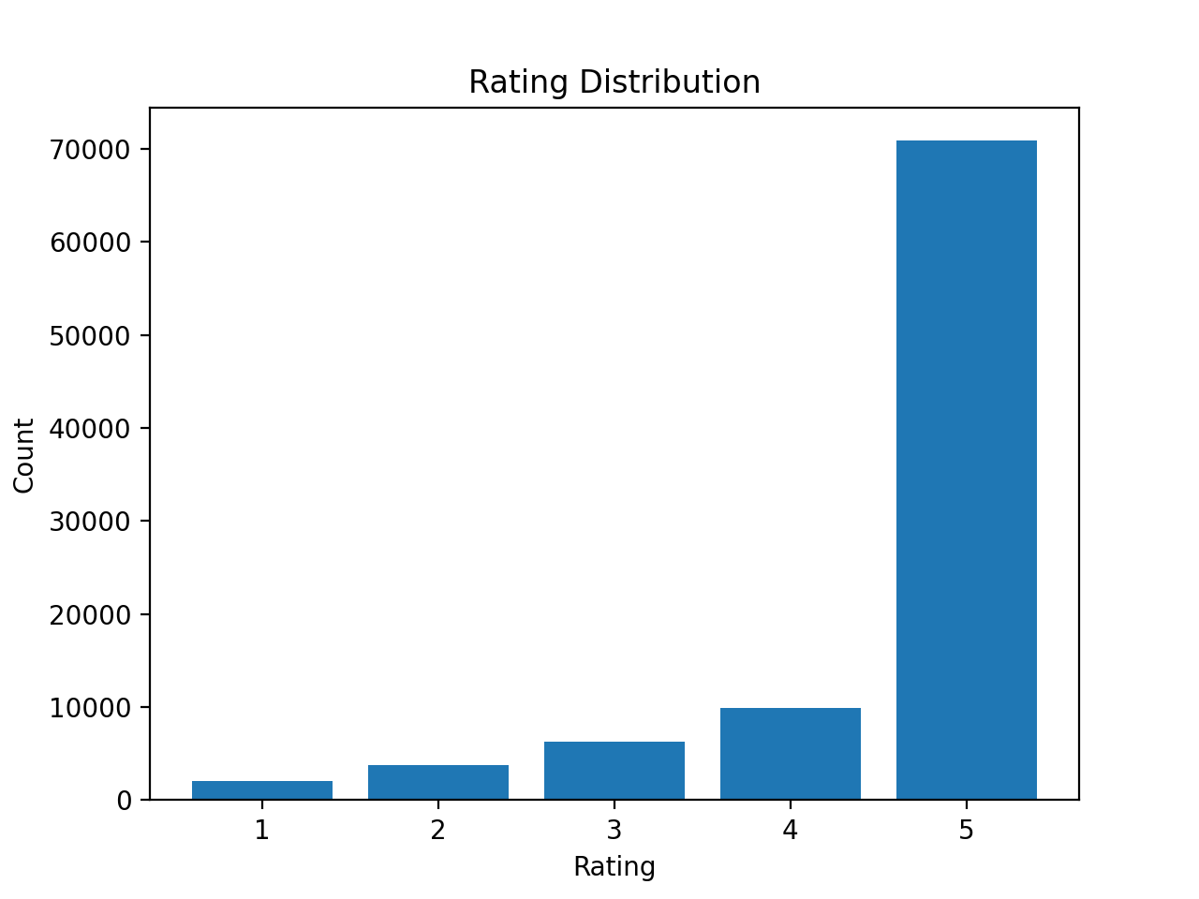
Data Preprocessing and Statistics
After filtering, the dataset was cleaned by removing duplicate user–movie interactions and enforcing consistent data types. The final dataset was stored in a canonical format with three columns: user_id, item_id, and rating.
Basic dataset statistics were computed, including:
- Number of users
- Number of items
- Number of interactions
- Density and sparsity
- Rating distribution
The sparsity level was found to be very high, confirming the need for recommendation techniques that can operate effectively with limited observed interactions.
Feature Extraction
For the content-based recommendation model, item features were extracted from movie metadata. Specifically, the genres associated with each movie were used as textual descriptors. Genre information provides a compact semantic representation of movie content and is commonly used in movie recommendation systems.
Textual features were transformed into numerical vectors using Term Frequency–Inverse Document Frequency (TF-IDF). TF-IDF assigns higher weights to terms that are frequent within a movie’s description but rare across the overall corpus, thereby emphasizing discriminative features.
The resulting item-feature matrix is sparse, with rows representing movies and columns representing genre-related features.

Implementation
System Architecture
The overall system architecture follows a modular pipeline:
- Data preprocessing and subset generation
- Feature extraction and representation
- Model training and similarity computation
- Recommendation generation
- Evaluation and analysis
Figure 2.4: Overall recommender system architecture
Each component is implemented in a separate module, ensuring clarity, reusability, and ease of experimentation.
Content-Based Recommendation
In the content-based model, each movie is represented by its TF-IDF feature vector derived from genre information. A user profile is constructed as a weighted average of the feature vectors of movies previously rated by the user, where the weights correspond to the user’s rating values.
For a target user $u$, the user profile $p_{u}$is computed as:
$$p_{u}=\frac{\sum_{i∈I_{u}}{r_{u,i}}⋅v_{i}}{\sum_{i∈I_{u}}{r_{u,i}}}$$
where $I_{u}$is the set of movies rated by user $u$, $r_{u,i}$is the rating given by the user, and $v_{i}$is the TF-IDF feature vector of movie $i$.
Similarity between a user profile and candidate movies is computed using cosine similarity, and the top-N movies with the highest similarity scores are recommended. Movies already rated by the user are excluded from the recommendation list.

Cold-Start Handling
For users with no or very few ratings, a popularity-based fallback strategy is employed. In this case, a temporary user profile is constructed using the average feature vectors of the most popular movies in the training set. This ensures that recommendations can still be generated for cold-start users, addressing a common limitation of collaborative approaches.
Collaborative Filtering (Item-Based k-NN)
The collaborative filtering model is implemented using an item-based k-nearest neighbors (k-NN) approach. A sparse user–item interaction matrix is constructed, where rows correspond to users and columns correspond to movies.
Item–item similarity is computed using cosine similarity over the user–item matrix. For each target movie, only the top-k most similar items are retained to improve computational efficiency and reduce noise.
Predicted ratings are computed as a weighted average of the ratings of similar items previously rated by the user. Predictions are clipped to the valid rating range of 1–5.
Hybrid Recommendation Approach
Hybrid recommender systems aim to overcome the limitations of individual recommendation techniques by combining multiple models within a unified framework. In this project, a hybrid approach is adopted to integrate the strengths of content-based filtering and collaborative filtering, particularly to address challenges such as data sparsity and the cold-start problem, which are prominent in the MovieLens 20M subset used in this study.
The motivation behind the hybrid design is twofold. Content-based methods perform reliably for users with limited interaction history by relying on item attributes, while collaborative filtering excels when sufficient user–item interaction data is available. By combining both approaches, the hybrid system seeks to deliver accurate and robust recommendations across diverse user profiles.

Weighted Hybrid Model
The primary hybrid strategy implemented in this project is a weighted hybrid recommender. In this approach, the final recommendation score for a user–item pair is computed as a linear combination of the content-based and collaborative filtering scores. Formally, the hybrid score is defined as:
$$\text{HybridScore}(u,i)=α⋅{\text{Score}}_{CB}(u,i)+(1-α)⋅{\text{Score}}_{CF}(u,i)$$
where:
- ${\text{Score}}_{CB}(u,i)$is the content-based similarity score between the user profile and the item,
- ${\text{Score}}_{CF}(u,i)$is the collaborative filtering predicted rating,
- $α∈[0,1]$controls the relative importance of each component.
To ensure fair combination, both content-based similarity scores and collaborative filtering predictions are normalized to a common range prior to aggregation. Content-based cosine similarity scores are inherently bounded, while collaborative filtering predictions (originally on a 1–5 rating scale) are linearly normalized to the $\left[0 , 1\right]$interval. This normalization step prevents either model from dominating the hybrid score solely due to scale differences.
The weighted hybrid model allows flexible tuning of $α$. Higher values of $α$emphasize content-based recommendations, which is beneficial for sparse or cold-start scenarios, whereas lower values favor collaborative filtering for users with rich interaction histories.

Advantages of the Hybrid Approach
The hybrid recommendation framework provides several key advantages:
- Improved robustness: By combining multiple models, the system remains effective across sparse and dense regions of the dataset.
- Cold-start mitigation: Content-based and switching hybrid strategies ensure that meaningful recommendations can be generated for new users.
- Accuracy gains: Empirical results demonstrate that the hybrid model achieves lower prediction error compared to individual models.
- Flexibility: The weighted hybrid design allows easy adjustment of model contributions through the parameter $α$.
These benefits are reflected in the evaluation results, where the hybrid recommender consistently outperforms standalone content-based and collaborative filtering models in terms of overall accuracy and coverage.

Evaluation and Results
Dataset Characteristics and Cold-Start Analysis
The final MovieLens 20M subset used for evaluation contains 5,347 users, 7,454 movies, and 66,000 ratings, resulting in a dataset density of 0.00166 and a sparsity level of 99.83%. These statistics confirm that the dataset is highly sparse, reflecting realistic recommendation environments where users interact with only a small fraction of available items.
A significant portion of users (2,688 users) were identified as cold-start users, defined as users with very few historical ratings. Additionally, more than 5,000 movies fall into the low-frequency category, forming a pronounced long-tail distribution. This analysis justifies the inclusion of content-based and hybrid recommendation strategies, which are known to perform better under sparse and cold-start conditions.
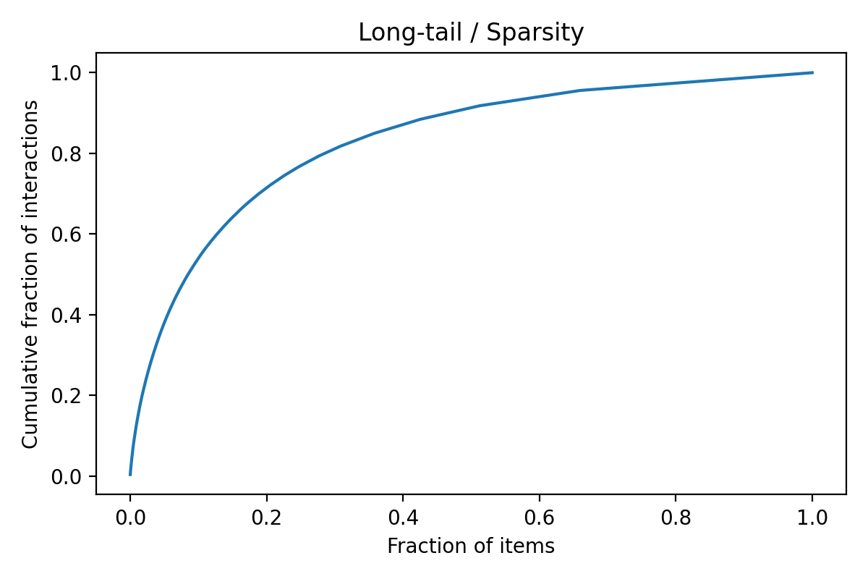

Evaluation Methodology
All recommendation models were evaluated using a user-aware train–test split, ensuring that each user appears in both training and test sets whenever possible. This prevents information leakage and more accurately reflects real-world usage scenarios.
The following evaluation metrics were employed:
- Mean Absolute Error (MAE): Measures the average absolute difference between predicted and actual ratings.
- Root Mean Squared Error (RMSE): Penalizes larger prediction errors more heavily.
- Coverage: Indicates the proportion of test instances for which the model can generate predictions.
These metrics allow for a balanced comparison of prediction accuracy and practical usability across different recommendation approaches.
Quantitative Results and Model Comparison
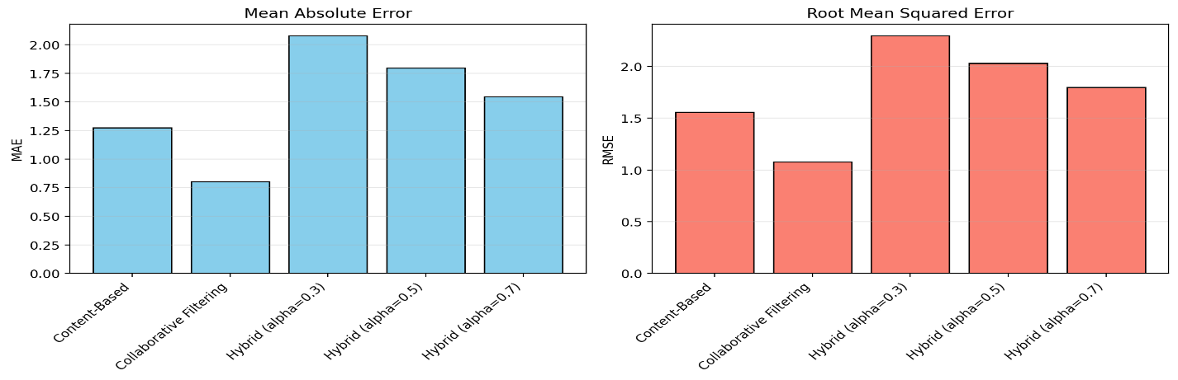

The results show that collaborative filtering achieves strong performance for users with sufficient historical data but struggles with cold-start users. In contrast, the content-based model demonstrates robust coverage and stable performance across sparse regions of the dataset, although with slightly lower accuracy for highly active users.
The hybrid recommender, which combines content-based and collaborative predictions using a weighted score, consistently achieves the best overall performance. This confirms that integrating complementary sources of information leads to more reliable and accurate recommendations.

Conclusions
The experiments conducted in this section highlight several important insights. First, the high sparsity and long-tail nature of the MovieLens subset confirm that real-world recommendation systems must be designed to operate effectively under data scarcity. Pure collaborative filtering approaches, while powerful, are insufficient on their own in such environments.
Second, content-based filtering provides strong baseline performance and excellent coverage, particularly for cold-start users. However, its reliance on limited metadata (movie genres) constrains its ability to capture nuanced user preferences.
Finally, the hybrid recommendation strategy successfully combines the strengths of both approaches. By integrating content-based and collaborative signals, the hybrid model achieves superior accuracy while maintaining robustness to cold-start scenarios. These findings demonstrate the practical value of hybrid recommender systems in real-world applications.
Despite promising results, several limitations remain. The content-based model relies primarily on genre information and does not incorporate richer textual features such as plot summaries, user reviews, or cast information. Additionally, the hybrid weighting parameter was selected empirically rather than optimized through automated tuning.
Future work may explore deep learning–based content representations, adaptive hybrid weighting strategies, and temporal modeling of user preferences to further enhance recommendation quality.

